

**DEPARTMENT OF INFORMATION & COMMUNICATION**

**TECHNOLOGY DFT3013 – WEB DESIGN TECHNOLOGIES**

**LAB EXERCISE 3**

|  |  |  |
| --- | --- | --- |
| **NAME** | **:** | NUR AZIZAH BINTI NASRIL  MUHAMMAD FAUZAN BIN MUSTAFFA |
| **REGISTRATION NO.** | **:** | 17DDT18F2010  17DDT18F2072 |
| **PROGRAMME** | **:** | DDT4E |
| **LECTURER NAME** | **:** | PN.NORQURSIAH BINTI SAAD |

|  |  |
| --- | --- |
| Page 1 (Registration.html) | Page 2 (Successful.html) |
|  |  |

**Questions**

1. Students are required to create a registration form as above.(Registration.html)
2. Students are required to include JavaScript elements and validation as below.
3. **Username**

* The value entered in username text field cannot be null or empty
* If empty, alert message will be issued (‘Please fill in your Username’)

*HTML Page*



*HTML Coding*

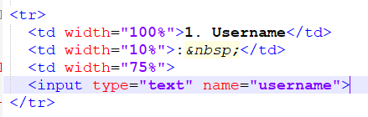

*CSS Coding*

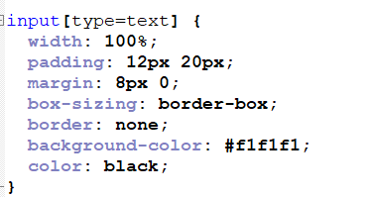

*Java Script*

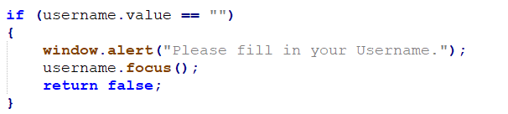

*Alert Massage*



1. **Password**

* The value entered must be more than 6 characters and cannot be null or empty
* If the value entered is less than 6 characters, alert message will be issued ('Please enter information more than 6 characters)
* If empty, alert message will be issued (‘Please fill in your Password’)

*HTML Page*

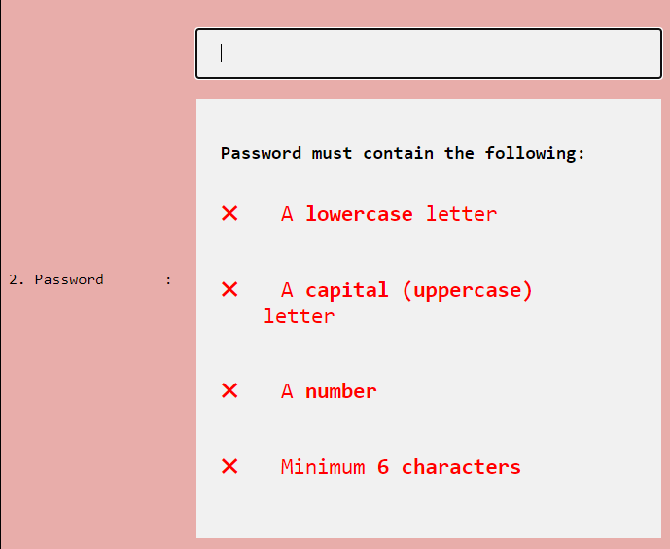

*HTML Coding*

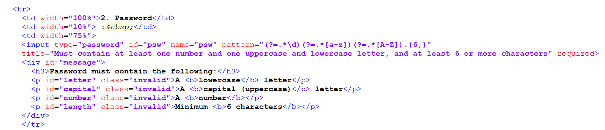

*CSS Coding*

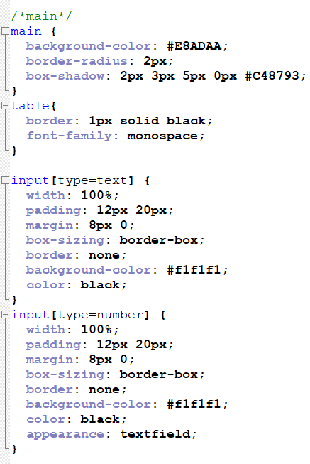

*Java Script*

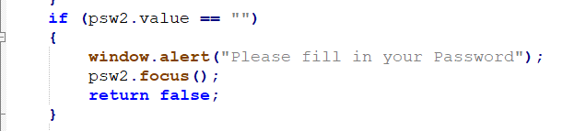

*Alert Massage*

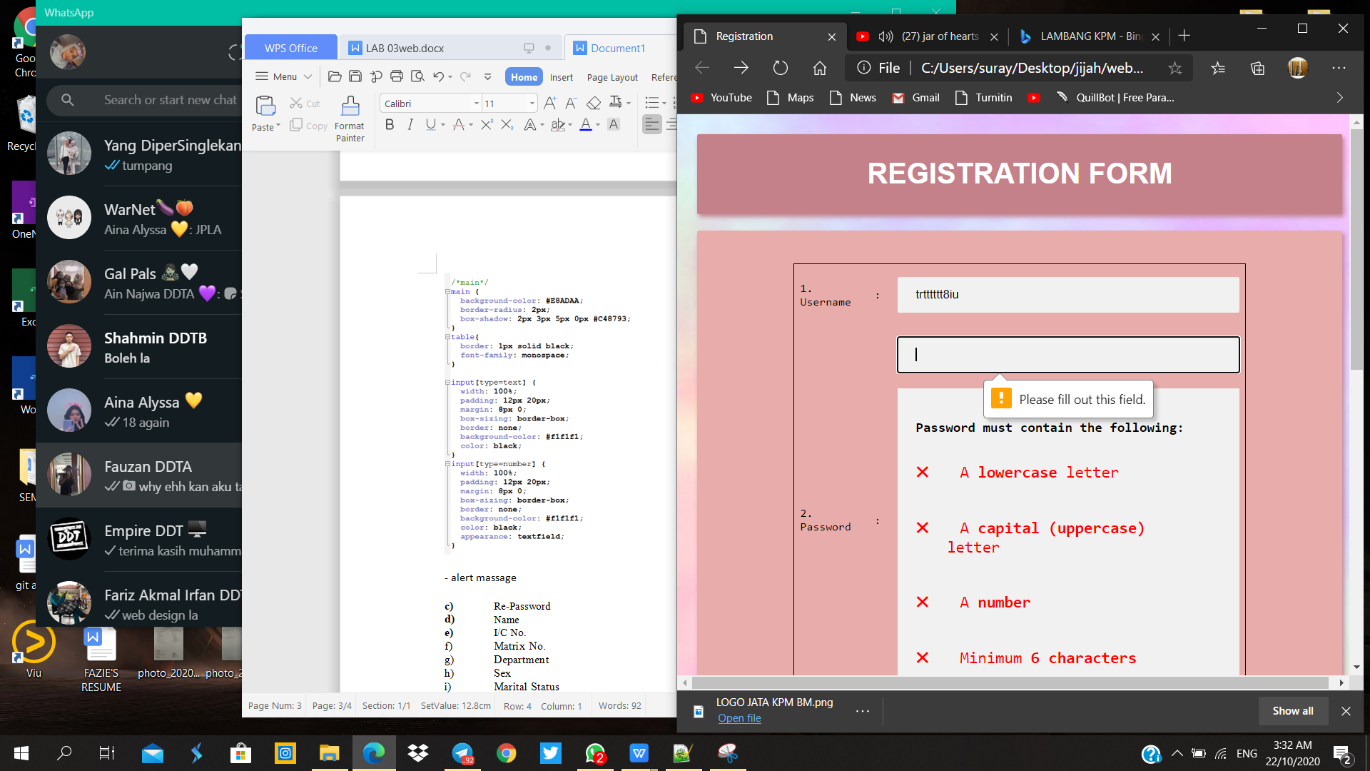

1. **Re-Password**

* The value entered in re-password text field cannot be null or empty
* If empty, alert message will be issued (‘Please fill in your Password’)
* The value entered should be equal to the value entered in the password
* If not the same, alert message will be issued ('Please enter the same password value')

*HTML Page*

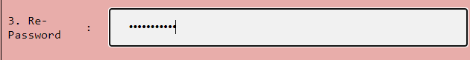

*HTML Coding*

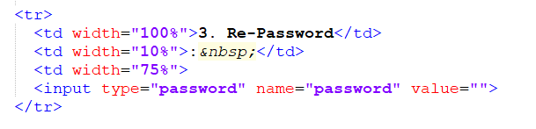

*CSS Coding*



*Java Script*

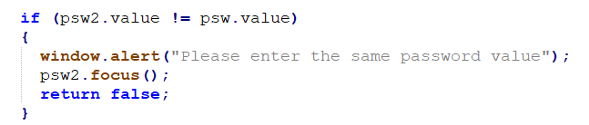

*Alert Massage*

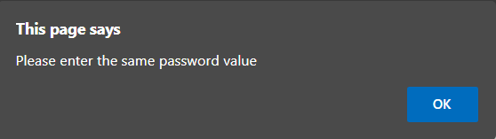

1. **Name**

* The value entered in name text field cannot be null or empty
* If empty, alert message will be issued (‘Please fill in your Name’)

*HTML Page*



*HTML Coding*

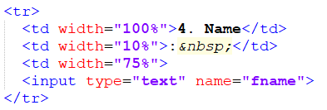

*CSS Coding*



*Java Script*

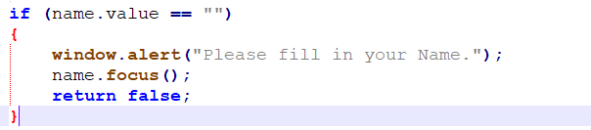

*Alert Massage*

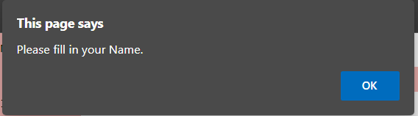

1. **I/C No.**

* The value entered must be 12 digits in the form of an integer value and cannot be null or empty
* If the value is more or less than 12 digits , alert message will be issued (‘Please enter 12 digits ic no’)
* If empty, alert message will be issued (‘Please fill in your IC No’)

*HTML Page*



*HTML Coding*

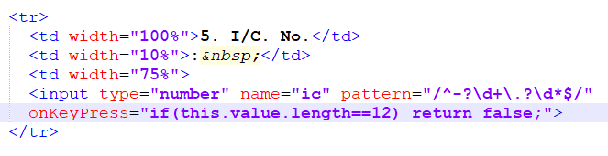

*CSS Coding*



*Java Script*

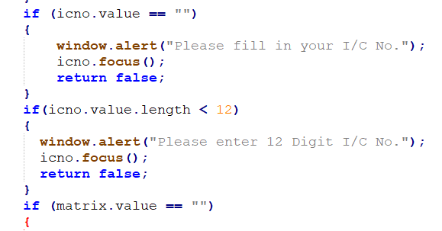

*Alert Massage*

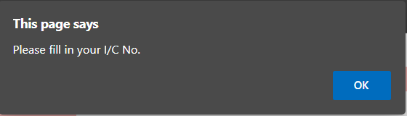

1. **Matrix No.**

* The value entered must be 12 digits in the form of string value and cannot be null or empty
* If the value is more or less than 12 digits , alert message will be issued (‘Please enter 12 digits Matrix no’)
* If empty, alert message will be issued (‘Please fill in your Matrix No’)

*HTML Page*



*HTML Coding*

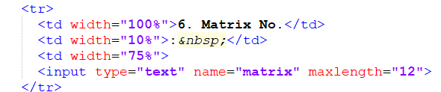

*CSS Coding*



*Java Script*

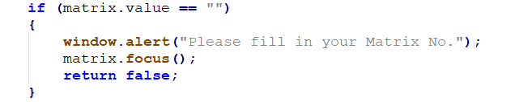

*Alert Massage*

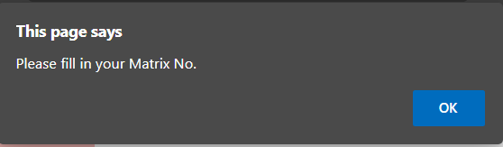

1. **Department**

* The value entered in department list menu cannot be null or empty
* If empty, alert message will be issued (‘Please fill in your Department)

*HTML Page*



*HTML Coding*

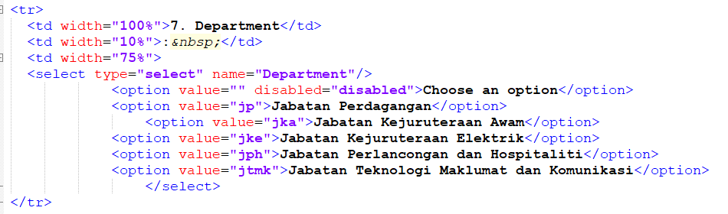

CSS Coding

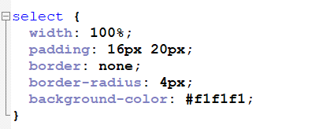

Alert Massage

1. Sex

* The value entered in Sex radio button cannot be null or empty
* If empty, alert message will be issued (‘Please fill in your Sex)

HTML Page

1. Marital Status

* The value entered in Marital Status radio button cannot be null or empty
* If empty, alert message will be issued (‘Please fill in your Marital Status)

1. Interest

* The value entered in Interest check box cannot be null or empty.
* If empty, alert message will be issued (‘Please fill in your Interest).

1. Address

* The value entered in Address text field cannot be null or empty.
* If empty, alert message will be issued (‘Please fill in your Address).